**Analytical investigation of reinforcement method using steel tube brace members**

1. **Definition of analysis model**

The model used to investigate the reinforcement method using steel tube brace members is a simple 2D steel frame structure, the dimensions of the frame are shown in Figure. 1.

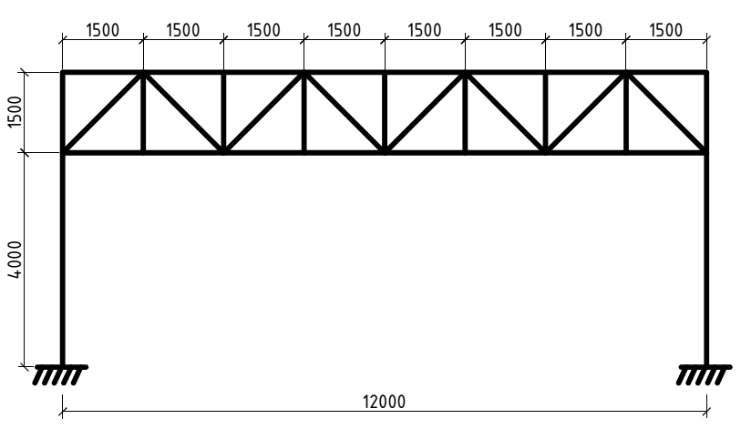

**Fig. 1.** The dimensions of 2-D steel frame (mm)

The steel frame consists of 2 round-hollow-section columns (HSS 550x12.5), the sections of the top and the bottom chord are also the pile section, they are HSS 500x20. The web elements are also the pile section (HSS 323.9x12.7). All structural steel were made from SKT500 whose the yielding stress is 325*MPa* and the tensile stress is 500*MPa*.

Chords and web elements are connected to each other through pin connection. The top of 2 columns are connected to the chords and the webs by pin connection, the bottom of the columns are fixed to the foundation.

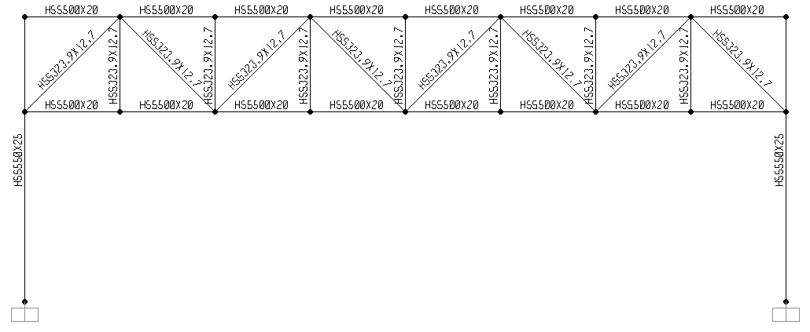

**Fig. 2.** The cross-sectional type of elements

The steel frame has been initially designed to carry a combination of Dead Load (DL) and Live Load (LL). The intensity of DL is 300*kN* and the LL is 150*kN* (the loads has been converted to the point load applied at the joint connecting the top chord element and the web elements. To analysis the structure, the proposed FEM program herein is SAP 2000 V14. To check the strength of all elements in the steel frame, we use the Design Option in SAP 2000 V14. The respective methods of checking and designing the strength of steel member are mentioned in ANSI/AISC-LRFD99.

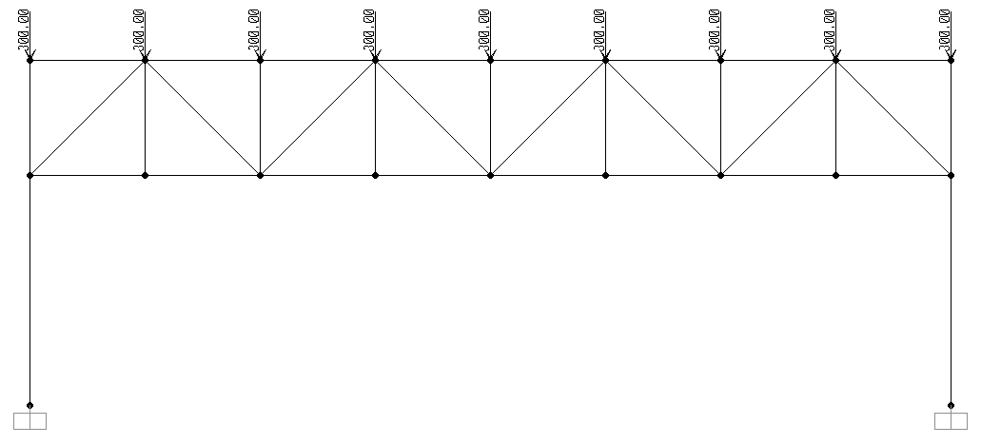

**Fig. 3.** Dead Load converted to Point Load

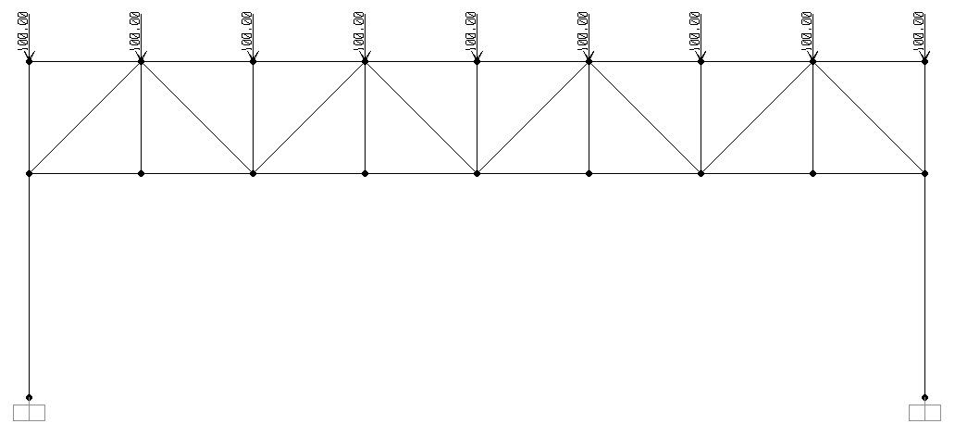

**Fig. 4.** Live load converted to Point load

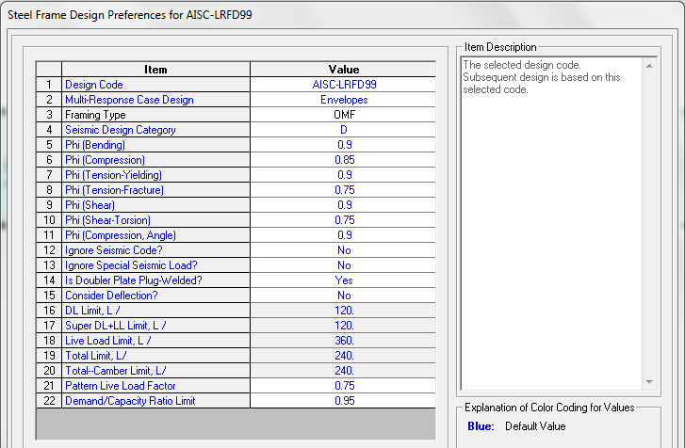

**Fig. 5.** Steel design option in SAP 200 with ANSI/AISC-LRFD99 code.

The results from SAP 2000 show us the P-M ratio, which shows the ratio of the internal forces (axial force, bending moment, torque moment, shear force) to the strength of material resisting to the corresponding effects (including axial force resistance and bending resistance). For instance, **Fig.4** shows the ratio of the axial force to the strength of the steel tube (either compressive strength or tensile strength) in web-components. In 2 columns, the ratio expresses the proportion of the value of the applied compressive axial force and moment to the strength of the column, which is calculated for the member subjected to combined axial force and moment. These numbers are calculated by the terms of ANSI/AISC-LRFD99 code. The maximum derived ratio is 0.852 < 1, therefore all members in the steel frame (columns, chords and webs) work properly with the application of original dead load (DL) and live load (LL).

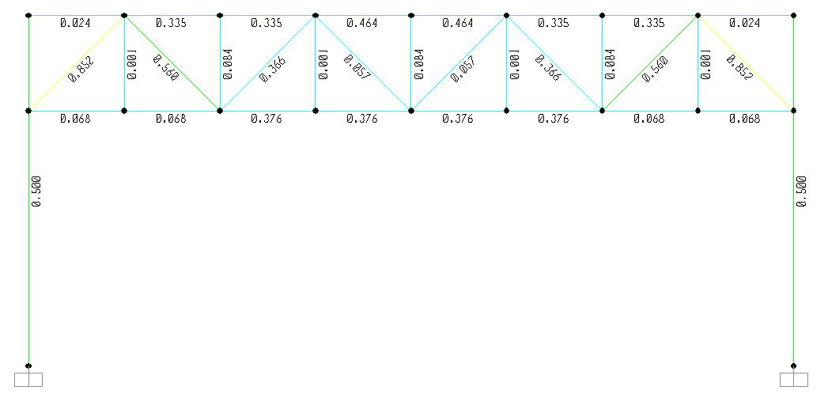

**Fig. 6.** Analyzed results derived by SAP 2000.

Another result should be satisfied is that the maximum displacement of the mid-point of the span must be smaller than *L*/360, with *L* is the span’s length. The derived displacement is 0.0163*m* < *L*/360 = 0.033*m*.

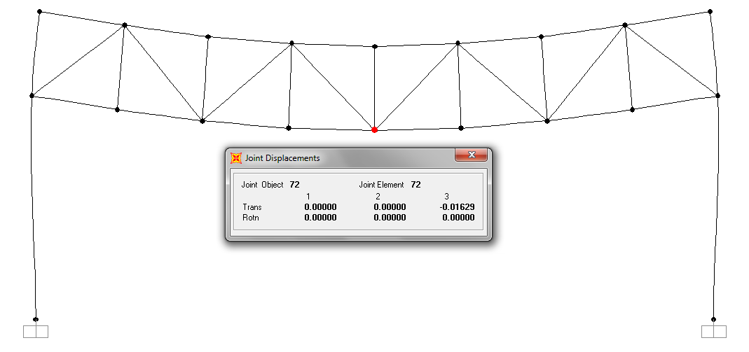

**Fig. 7.** Maximum displacement of the mid-point of the span.

The results above show that the steel frame has been designed sufficiently to carry a combination of Dead load and Live load.

The problem given herein is that if there is an additional load applied in the top chord of the structure (it may be a new story or sub-structure built on the top of the steel frame), all members of steel frame will have to work properly and the displacement must be smaller than the allowable displacement. The additional loading has the intensity of 900*kN*, distributed in a length of 4.5*m.*

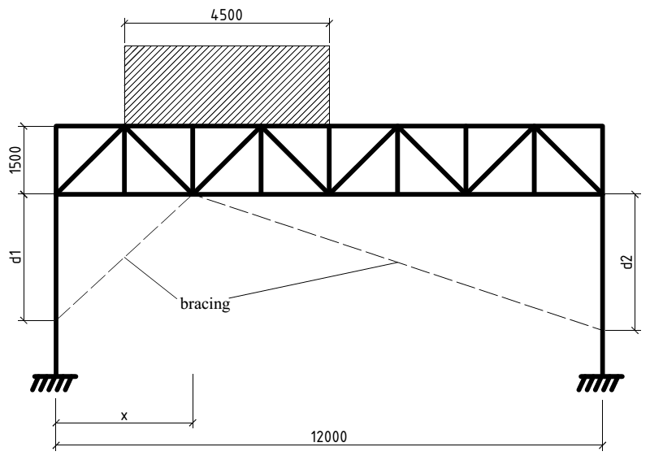

**Fig. 8.** Analytical model

To assure that the structure still works properly within strength conditions and service condition, the solution is using bracing as a reinforcement method. The chosen bracing herein is steel tube brace members, namely the HSS486x23 structural steel tube. The yield strength and tensile strength of the steel tube are 590*MPa* and 700*MPa*, which are corresponding to UL700 structural steel.

1. **Investigate optimal brace location and relationships among each parameter.**

To investigate the optimal bracing location (the connection joint of the bracing members with column and bottom chord), 2 parameters have been taken to account. The first parameter *∆S* is the P-M ratio of the applied force to the resistances of each member, which are determined by SAP 2000 through the terms of ANSI/AISC-LRFD99 steel designed code, the second *∆D* is the value of displacement of the mid-point of the span. Obviously, the displacement must be smaller than the limited displacement claimed by the building design code. The smaller values of *∆S* and *∆D*, the better result of bracing location we can get. Besides the parameters which evaluate the efficient of using bracing to support the additional loading, there are 2 parameters can be used to evaluate the propriety and the economics of chosing the brace section, they are the *∆’S* – the ratio of the applied axial compressive force to the axial compressive strength and the total length of the braces – *lb*.

There are 3 concerned parameters: *d1, d2* and *x1*. Besides that, we consider 2 locations of the additional loading.

*d1* is the location of the connection joint between *Brace 1* and column 1, *d1* varies from 4*m* to 0*m* with the decreasing step is 2*m*. Similar to *d1, d2* describe the location of the connection joint between brace 2 and column 2, it also varies from 4*m* to 0*m*.

*x1* is the location of the connection joint between *Brace 1*, Brace 2 and the bottom chord. Since the frame is symmetric, *x1* has 4 values: 1.5m, 3m, 4.5m, 6m respective to the location of the joint of the truss.

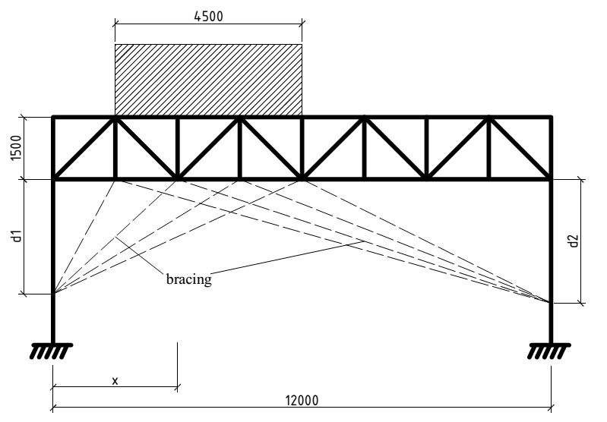

**Fig. 9.** Different cases of bracing’s location.

There are 2 cases of loading’s location, the additional load is located on the left side of the frame and the center of the frame. It is not necessary to consider the case of locating the additional load on the right side of the frame as the frame is symmetrical about the central vertical line.

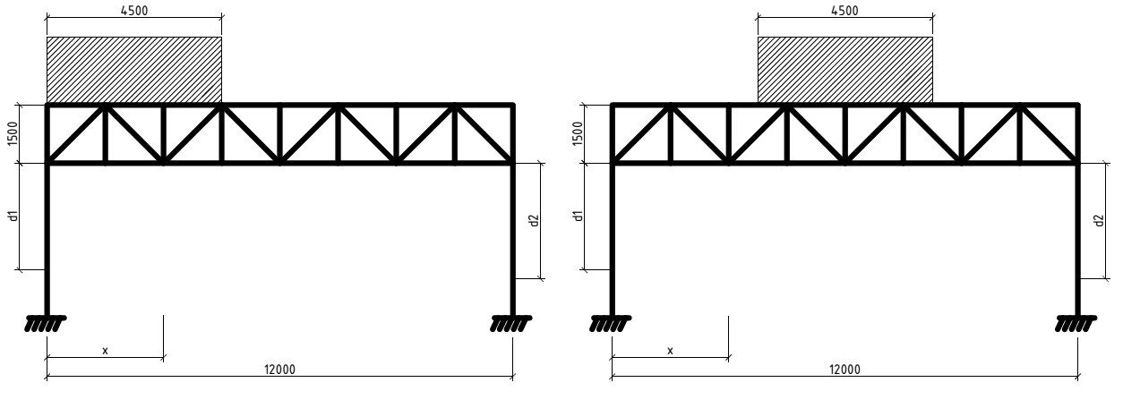

**Fig.10.** 2 cases of loading location.

1. ***Analysis results and discussion***

The first case to consider is the case whose the additional load is applied on the left of the steel frame. The additional live load whose intensity is 900*kN* and spreaded in a length of 4.*5m* is convert into point load. **Fig. 11** shows the additional live load applied to the joints on the left side of the frame (the original live load applied at nodes is 100*kN*).

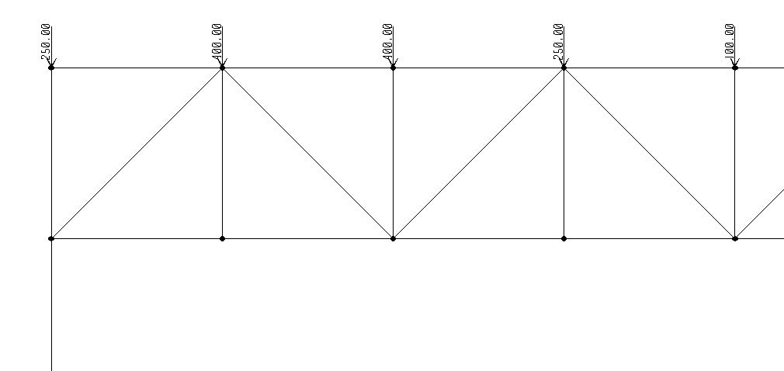

**Fig.11.** The additional live load applied at joints.

By using SAP 2000, the results of displacement and the P-M ratio in the members of the frame are shown in **Fig. 12** and **Fig. 13.**

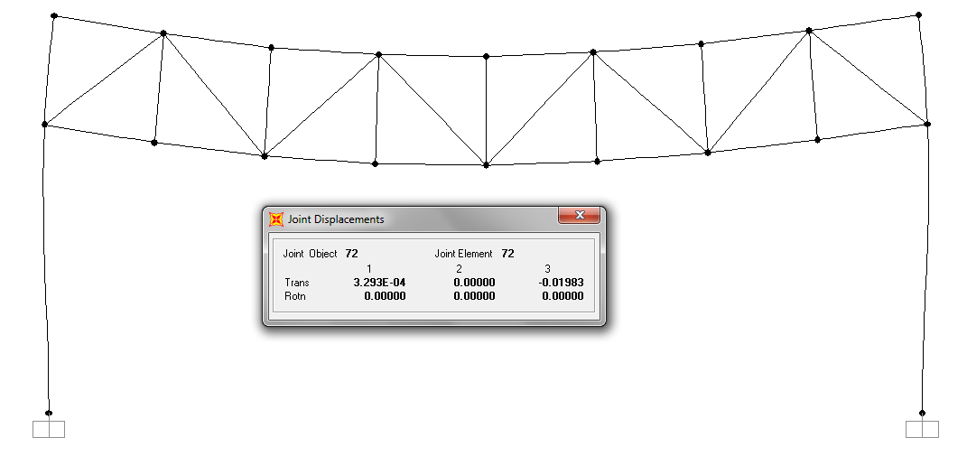

**Fig.12.** Joint displacement when applied additional live load.

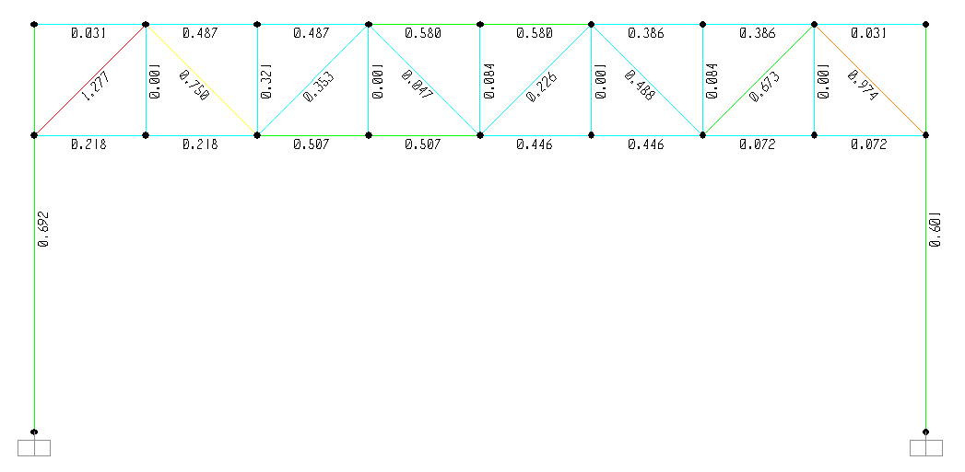

**Fig.13.** P-M ratio when applied additional live load.

It can be seen that when the additional load is applied, the displacement of the mid point of the span has increased and the P-M ratio has exceeded 1, which

|  |  |  |  |  |  |  |  |
| --- | --- | --- | --- | --- | --- | --- | --- |
| ***Load case*** | ***d1 (m)*** | ***d2 (m)*** | ***x1 (m)*** | ***Δd (mm)*** | ***Δs (frame)*** | ***Δs (brace)*** | ***Brace length L (m)*** |
| I | 0 | 0 | 0 | 19.83 | 1.277 |  |  |
| I | 2 | 2 | 1.5 | 16.7 | 0.914 | 0.068 | 13.19 |
| I | 2 | 2 | 3 | 15.83 | 0.911 | 0.066 | 12.83 |
| I | 2 | 2 | 4.5 | 15.97 | 0.98 | 0.059 | 12.69 |
| I | 2 | 2 | 6 | 15.58 | 1.076 | 0.059 | 12.65 |
| I | 2 | 4 | 1.5 | 15.49 | 0.863 | 0.082 | 13.74 |
| I | 2 | 4 | 3 | 12.67 | 1.101 | 0.087 | 13.45 |
| I | 2 | 4 | 4.5 | 11.76 | 1.159 | 0.08 | 13.42 |
| I | 2 | 4 | 6 | 10.13 | 1.213 | 0.079 | 13.54 |
| I | 4 | 2 | 1.5 | 14.86 | 0.865 | 0.084 | 14.96 |
| I | 4 | 2 | 3 | 11.79 | 1.085 | 0.085 | 14.22 |
| I | 4 | 2 | 4.5 | 11.15 | 1.11 | 0.078 | 13.78 |
| I | 4 | 2 | 6 | 10.06 | 1.126 | 0.082 | 13.54 |
| I | 4 | 4 | 1.5 | 13.61 | 0.954 | 0.095 | 15.51 |
| I | 4 | 4 | 3 | 7.95 | 0.691 | 0.102 | 14.85 |
| I | 4 | 4 | 4.5 | 6.12 | 0.817 | 0.094 | 14.52 |
| I | 4 | 4 | 6 | 3.37 | 0.691 | 0.097 | 14.42 |

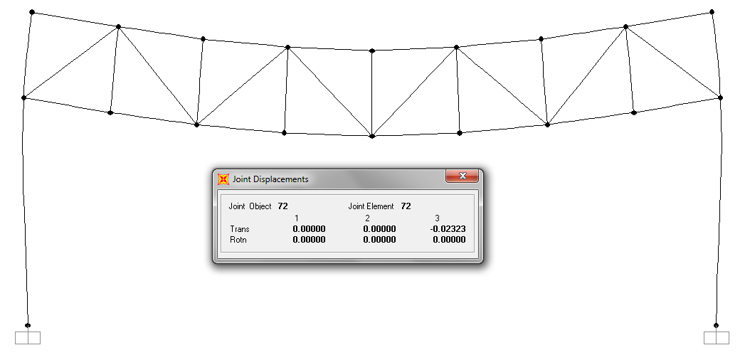

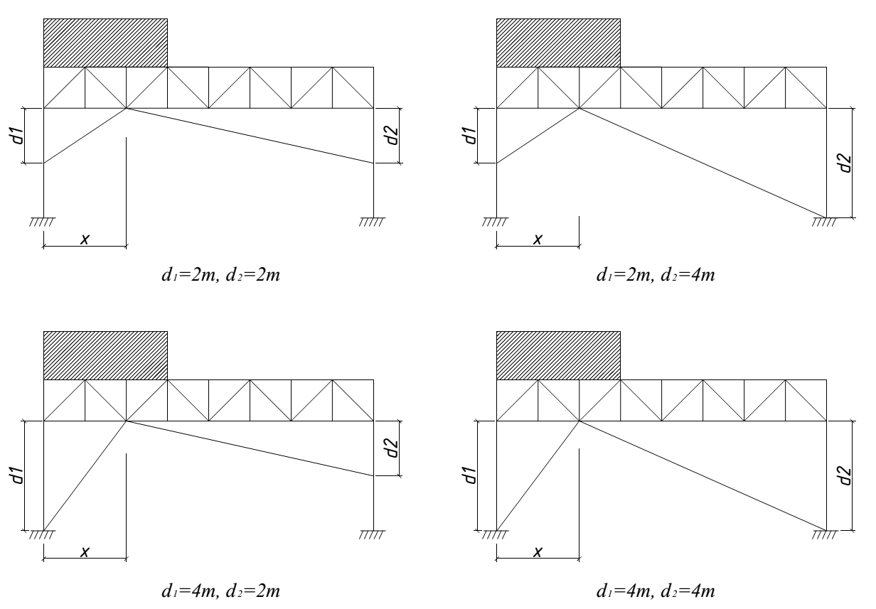

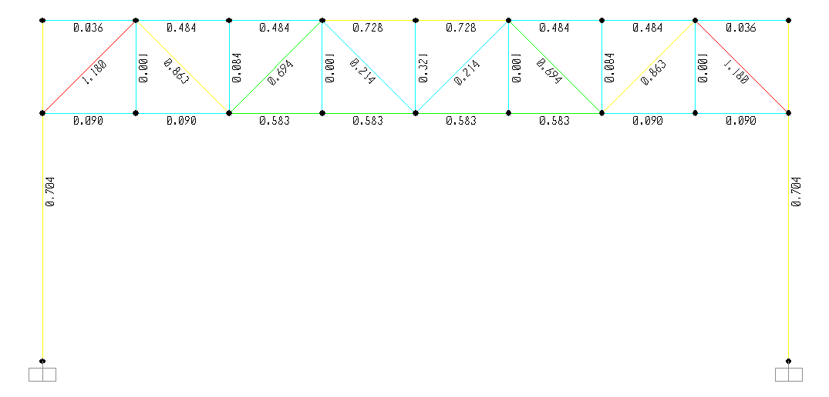

1. ***Conclusion***